|  |
| --- |
| Circle Language Spec: System Objects |

## System Interface of a Related List

When you open up the system interface for a Related List, you get to see the system commands that apply to Related Lists. Only the List aspect applies to Related Lists. The system interface of a Related List will show the Add command. The Add command has an optional Item argument, to add an existing item to the list.

So the system interface of a Related List looks like this:

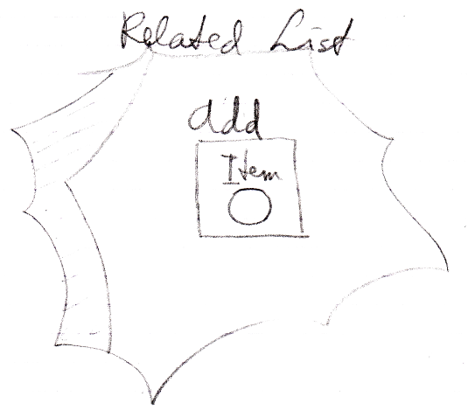

But more members may be introduced later. Specifically you would probably would want to centrally control the Class aspect of all the items in the list.